After backup report generated, need to make changes in lambda fuction.

Steps :

1. Go to atos-tooling-pr (EMEA) > lambda > search "1DN9PBWLV8X67" > click on "lambdas.py"

**We need make changes every month 1st date in all lambda jobs.**

For example:

changes made on 1st Feb-2021 like as below.

END_DATE

2021,

2,

28,

START_DATE

2021,

2,

1

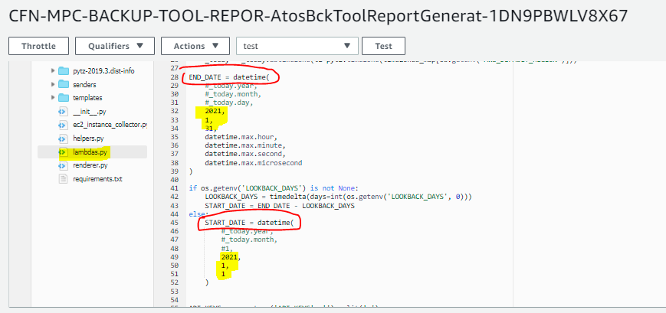

1. Once changes done, click on Deploy

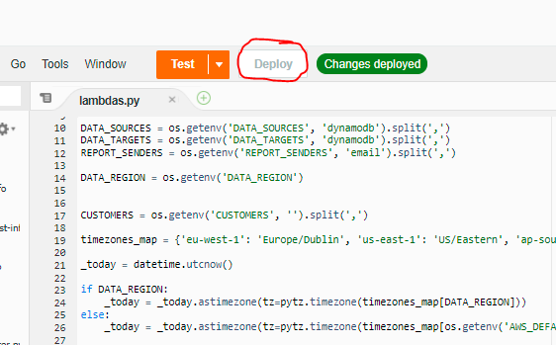

1. Follow same steps for below lambda function.

***Philips reportGenerator: ( Need to change) -*** -EMEA Region

CFN-MPC-BACKUP-TOOL-REPOR-AtosBckToolReportGenerat-1DN9PBWLV8X67 (phht-gen-ra1-pr)

CFN-MPC-BACKUP-TOOL-REPOR-AtosBckToolReportGenerat-1KLA6AOXPA9I6 (phht-gen-ra2-pr)

CFN-MPC-BACKUP-TOOL-REPOR-AtosBckToolReportGenerat-14SS6DLPJRTWA (phht-gen-ra3-pr)

CFN-MPC-BACKUP-TOOL-REPOR-AtosBckToolReportGenerat-1GN65AC9JS6N6(AWS-P12-RA01-P) – No needed

CFN-MPC-BACKUP-TOOL-REPOR-AtosBckToolReportGenerat-BMAWMZ77GP22(AWS-P12-RA01-NP) – No needed

***Britvic reportGenerator ( Need to change)*** -EMEA Region

CFN-MPC-BACKUP-TOOL-REPOR-AtosBckToolReportGenerat-12E22ZWRVOXCS ( Britvic-gen-ra1-pr)

CFN-MPC-BACKUP-TOOL-REPOR-AtosBckToolReportGenerat-1IZ71Q11F6U8C ( Britvic-gen-ra2-pr)

CFN-MPC-BACKUP-TOOL-REPOR-AtosBckToolReportGenerat-GOCRC9CONH3K ( Britvic-gen-ra3-pr)

CFN-MPC-BACKUP-TOOL-REPOR-AtosBckToolReportGenerat-FSD4MGKZF7P3 ( Britvic-gen-ra4-pr)

***ATOS-TOOLING-PR reportGenerator ( Need to change)-*** -EMEA Region

CFN-MPC-BACKUP-TOOL-REPOR-AtosBckToolReportGenerat-Q5GWOBWGCRJD (NAM) – No needed

CFN-MPC-BACKUP-TOOL-REPOR-AtosBckToolReportGenerat-1EMX0FTW4BC9C (EMEA)

CFN-MPC-BACKUP-TOOL-REPOR-AtosBckToolReportGenerat-N7B10UX11VJZ (APAC)